Biology Extended Essay

Title: Effect of video games on reaction time in high school students using their dominant and non-dominant hand.

Research question: To what extent does playing video games using the dominant versus the non-dominant hand affect reaction time in high school students?

Word Count: 3978

Table of Contents
Research question: 1
Introduction 3
Reaction time 3
Dominant and non-dominant hand 6
Video games 8
Experiment 10
Aim 10
Hypothesis 10
Null hypothesis 10
Variables 10
Apparatus/ equipment 12
Safety 14
Ethics 14
Method 15
Data and analysis 16
Paired t-test 18
Discussion 21
Evaluation and improvements 22
Conclusion 24
Bibliography 26
Appendices 29
Appendix 1 - Raw data 29
Appendix 2 - Information sheet 34
Appendix 3 - Consent form 35
Appendix 4 – t-test calculations 36

To what extent does playing video games using the dominant versus the non-dominant hand affect reaction time in high school students?

Introduction

Reaction time refers to the time that takes place between when we perceive something to when we respond to it. It is the ability to detect, process, and respond to a stimulus. (Anonymous, 2017) This is crucially important in our everyday lives. For example, you are driving and you come across a crosswalk, the time that it takes from when you see the crosswalk to when you break and stop the car would be reaction time, these responses prevent us from many dangerous car accidents. (Anonymous, 2017)

This is why reaction time is a crucial mechanism that is driven by our central nervous system (CNS) and the neurons in our body. I decided to investigate the reaction time in high school students using the dominant versus the non-dominant hand after playing video games because video games can affect reaction time therefore it can increase the reaction time in dominant or non-dominant hand, many people in our era play video games so it would be useful to know if its affect is beneficial or not.

Reaction time

Reaction time is the interval time between the presentation of a stimulus and the initiation of the muscular response to that stimulus (Mackenize, 1998). For the purpose of this study a stimulus is defined as “a change in the environment either internal or external that is detected by a receptor and elicits a response. (Walpole, 2014) So, if there is one simple response which is a reaction or a change in an organism as a result of a stimulus (Walpole, 2014) it will only take a short time to react to it, however if there are several responses then it will take a longer time to determine which response to react to (Mackenize, 1998) and the flow of information can be represented in the image below.
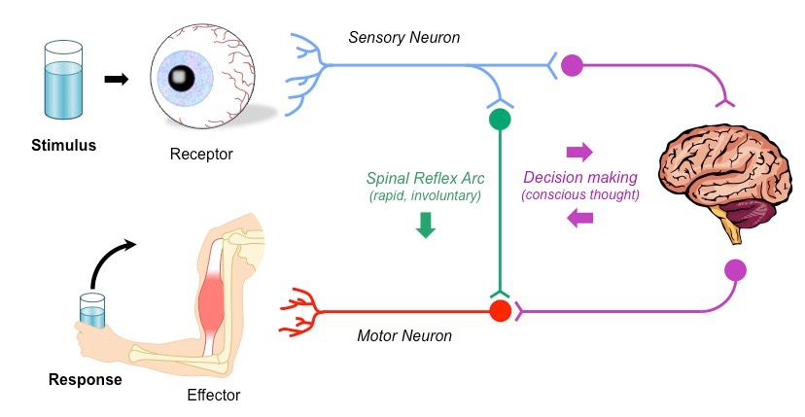

Figure 1 –Shows the information flow within an organism. (IB BioNinja)
Reactions are voluntary responses whereas reflexes are involuntary or unintentional (Hammond, n.d) There are many types of receptor which is a special protein in the membrane of neurons. Some receptors respond to pressure when the cell is compressed so the receptors are activated letting the brain know that something is pressing on the skin or organs. While other receptors respond to pain such as chemical stimuli like smell or taste and finally the ear can respond to vibrations in the air that is interpreted as sound and receptors in the eyes respond to light.
So usually when the body detects a stimulus it starts with the receptor such as in the eyes, nerve impulses are carried by neurons to effectors which are either muscles or glands. The effectors carry out the response. This pathway usually involves the CNS which involves either the brain, the spinal cord, or both.
The neuron that carries the impulse from the receptor to the CNS is called the sensory neurones and they are cells that contain sensory receptors. They activate when the receptors get an indication from the surroundings or the environment, which extends into the spinal cord sending an electrical signal all the way to another neuron, the interneuron.
The interneuron connects sensory input to other cells that are essential for action. During a reflex arc, sensory neurones sends a message to the interneuron and activate it, then afterwards the interneuron relays that message to the motor neuron. These neurones run from the spinal cord and connect with a muscle.
Therefore, the muscles allow us to take action which is when we move our hand or any body parts away from the stimuli. Essentially, a reflex arc only involves a few neurons or cells of the nervous system and that information goes from the body to the spinal cord. The speed of reflex is greater than that of a voluntary reaction (Hammond, n.d) the average reaction time for a visual stimulus is 200 to 250 ms and for touch is 130 to 170 ms (Hammond, n.d) this would help understand how the participants in this study would be reacting to the stimulus given and the reaction time test.
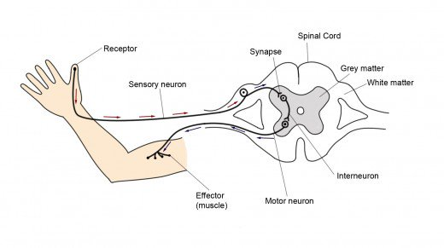

Figure2 – A reflex arc which shows the nerve pathway that is involved in a reflex action. (Custers, 2017)

Dominant and non-dominant hand

Handedness had considered not only a natural and non-invasive marker of functional asymmetry but also a hallmark of human evolution (Li et al, 2014) there are more right-handed people that left-handed people and that could be due to genetics or evolution. Handedness occurs due to the lateralization which is the tendency for a few neural functions or cognitive processes to be occurring more often in one hemisphere than the other. There is some crossing of nerves between the body and the brain, which means it is actually the left side of the brain that has more control over the right side of the body, in other words the brain’s left hemisphere helps control the operation of the right hand, right eye, right leg and so on. So, the right side of the brain has more control over the left body parts, left hand and left eye.

There are two theories about why we have dominant and non-dominant hand, first one is that it is mainly produced by biological and most likely genetic causes. A study was conducted on patients with dyslexia, the article mentions
“The researchers observed that patients with dyslexia exhibited a correlation between the gene PCSK6 which is a protease that trigger the development of left and right asymmetry and handedness, however afterwards the researchers observed non-dyslexic patients found that PCSK6 didn’t work alone in affecting handedness in the general population. Other genes, also responsible for creating left-right asymmetry in the body, were strongly associated with handedness. This gene has an effect on handedness but depends on how many mutations the alleles undergo. Each gene has the potential for mutation, the more mutations a person has in any one direction towards right handedness or left handedness the more likely they are to use that hand as their dominant hand.” (Geiling,2013)

It was later explained that all these genes are linked to the development of left-right asymmetry in the body and the brain which are consistently asymmetric in all normal individuals (Levin, n.d) This creates a strong case for correlation between development of this symmetry and the development of handedness, causing disruption to any of these genes could lead to serious physical asymmetry, like Situs inversus which is a congenital condition where organs are mirrored to the opposite normal position. (Natasha Geiling, 2013).

The second theory is evolution; we know now that animals do have leg preferences and they most likely had that billions of years ago and it has evolved.
“Hopkins offers some examples from his own research: In chimpanzee populations, about 65-70 percent are right-handed. Gorillas are about 75 percent right handed. On the other hand, about 66 percent of orangutans are lefties.’’ (Wetsman, 2016)

Goldman (2014), says in an BBC article “The stone tools that were made 1.5 million years ago in Kenya by two ancient human species – Homo habilis and Homo erectus – do show some evidence of species-wide right-handedness. Therefore, by the time called Homo heidelbergensis had appeared, around 600,000 years ago there was a clear right-handed preference in prehistoric societies. Where on the preserved teeth of Homo heidelbergensis, for instance, suggest that food was usually brought to the mouth with the right hand. So, this links to the fact that being right handed or left handed goes back to evolution and our oldest ancestors.” (Goldman, 2014)

In my study, I am trying to find out if people have a faster reaction time in their dominant hand than non-dominant hand and if it relates back to the hemispheres of the brain and their physiological abilities and if gene mutation and evolution play an important role in hand preferences.

Video games

A factor that affects reaction time is video games, which have been proven to be very popular with the current generation. There were about 1.8 billion people worldwide that play video games in 2016, (Mackane, 2016) and the average age for video game players is 35, more gamers are over the age of 36 than between the age of 18/25 or under the age of 18 (Grubb, 2014)

There are also positive aspects about playing video games, according to a study conducted by cognitive scientists from University of Rochester, stating that “ video game players develop a heightened sensitivity to what is going on around them, and this benefit doesn’t just make them better at playing video games, but improves a wide variety of general skills that can help with everyday activities like multitasking, driving, reading small print, keeping track of friends in a crowd, and navigating around town.” (Blank-Rochester, 2010)

Also, Bavelier (2014), who studies cognitive and neuroscience, conducted a study on brain and video games and the article went on to explain her findings:
“Findings were that gamers have better vision, gamers could make out small details better and could distinguish between shades of greys which is useful for driving in foggy conditions.” “Second gamers are better at focusing their attention, gamers can track more objects at a time and focus on tests for longer. And that gamers are better multi-taskers, they can switch from one task to another with minimal cost. “(Tedsummaries, 2014)

Considering the effects of video games on the autonomic nerves, a few studies have reported that playing video games can increase heart rate, blood pressure and oxygen consumption. Autonomic nerves are those connected with involuntary internal organ processes, such as breathing and heart rate. Heart rate can be altered by electrical signals from emotional centers in the brain or by signals from the hormones called epinephrine (adrenaline) and norepinephrine. These hormones are released from the adrenal glands in response to danger. (Kardars, 2004)

Experiment

Aim
To investigate the reaction time in students using the dominant versus non-dominant hand.

Hypothesis
Using the dominant hand while playing video games will lead to an increase in reaction time in the dominant hand compared to the non-dominant hand.

Null hypothesis
Using the dominant hand while playing video games will have no effect on the reaction time in the dominant hand compared to the non-dominant hand.

Variables

Independent variable | Dependent variable
- Playing video games for 5 minutes using dominant and non-dominant hand.  - Males and females playing video games for 5 minutes. | - Reaction time (s) in the dominant and the non-dominant hand.

Control variable | Why controlled | How it is controlled
- The game the participants are going to play. | All 100 participants will experience fairly the same effect of playing video games. It is a simple old game that requires barley any hard work, just concentration. | All participants are going to play a simple cognitive game (Brain Metrix Cognitive Training)
- The time the participants will spend playing the game. (5 minutes) | 5 minutes is a good enough time for participants to concentrate playing the game and not get distracted because it is short and effective. | All participants will play the game for 5 minutes.
- All participants will be taking the same test. (SRT Online) | Participants will be taking the same test for all the reaction time to be accurate. Many studies used this online reaction time before so it is reliable. | Simple Reaction Test online.
- Participants’ ages (years) | Participants are all in the range of 14 to 18 years old, this would help me collect data from a specific age group and I chose this age because this is the age of teenagers spend a lot of their time playing video games. | All 100 participants will be from the age 14 to 18 years old.

Apparatus/ equipment

Equipment | Reason
- Laptop/computer. (Dell Latitude core i7) | For participants to play the game online.
- Chair. | For the participants to feel comfortable while playing the video game and taking the SRT online and also to be able to concentrate since it requires a bit of concentration to accurately preform.
- Video game online.  (http://www.brainmetrix.com/cognitive-training/) | All participants can access it and appropriate to use and requires no effort.
- Simple Reaction Test Online. (https://faculty.washington.edu/chudler/java/redgreen.html) | Most accessible for the participants and also it is a better reliable way to collect reaction time data and been used many times by other researchers.
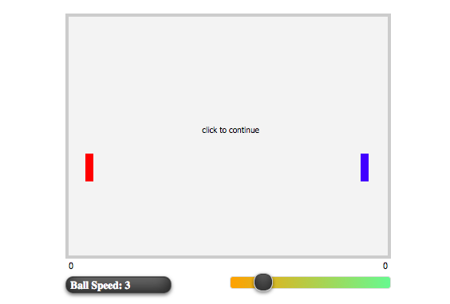

Figure 3 - Brain Metrix game that the participants are going to play.
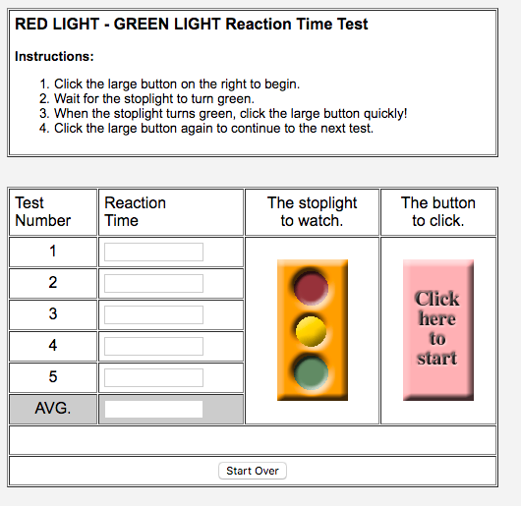

Figure 4 – Simple Reaction time test online for participants to take.

Safety

Safety | Reason
- Don’t use violent video games. | To avoid getting participants under stress.
- Use Simple Reaction Test. | To avoid making the participants feel under pressure.
- Make the participant sit on a comfortable chair. | To avoid the participants feeling physically uncomfortable.
- Make sure the room is quiet and well lit. | So the participants are able to focus and not getting distracted.

Ethics

- Participants are given information sheet to read which explains the nature of the experiment.
- Participants are given a consent form to sign and agree on participating in the experiment.
- Participants are able to withdraw from the experiment at any time.
- Participants’ results remain confidential.
- Participants’ names remain confidential and will not be used in the data analysis.

Method

- Participants will be asked to come to a quiet room where the experiment will take place.
- I will be setting up the simple reaction test and the game the participants are going to play on the laptop/computer, all participants will be using the same websites for the simple reaction test and the game for the experiment to ensure consistency.
- The participants will be given the information sheet and the consent form to read and sign and return.
- Participants will be given a table in which they will record their name, age, year and scores during each trial.
- The participants will be using the simple reaction test involves responding to a light stimulus which will then require the participant to click on the button when the the traffic light turns green, which will then give the participants their score. The participants will be taking the simple reaction test before playing the video game using their dominant and non-dominant hand and then they will be asked to record it in a table which will be given to them.
- The participants will begin the experiment.
- Participants will then play the game for 5 minutes, using their dominant hand.
- Participants will take the simple reaction test using their dominant hand and record their scores on the sheet given. They will repeat the reaction test for 5 times for more accuracy.
- Participants will take the simple reaction test this time using their non-dominant hand and repeat it 5 times to compare the results and they will record their scores on the sheet given.
- Participants will be asked to play the game again using their non-dominant hand for 5 minutes.
- Participants will take the simple reaction test using their dominant hand 5 times and record the results on the sheet given.
- Participants will take the simple reaction test using their non-dominant hand and repeat 5 times then record their results on the sheet.

Data and analysis

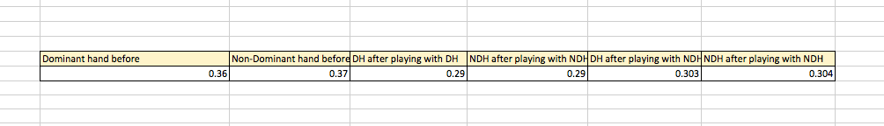
The table below shows the average taking from the 100 participants raw data (See appendix 1) for SRT before and after with dominant and non-dominant hand. From the average calculated we can clearly see that the difference between dominant and non-dominant hand in SRT is small but must be proven significantly with statistical analysis.

Figure 5 - Average taking from 100 students showing the dominant vs the non-dominant hand done on Microsoft Excel.

Figure 6 - Bar graph done on Microsoft Excel to show the difference between dominant and non-dominant hand after the experiment.

To have clear results between the dominant hand and the non-dominant hand I choose to do a bar graph to show the data collected because I have more than one data set. From the bar graph, we can see that the dominant hand is faster than the non-dominant hand, the dominant hand is 0.36 (s) the and non-dominant hand is 0.37 (s), also when playing video games with the non-dominant hand there is a difference between the non-dominant hand and the dominant hand, the dominant hand is faster by 0.303 (s) and the non-dominant hand is 0. 304 (s) However, there is no difference the two after playing video games with the dominant hand.

Paired t-test

The paired sample t-test is a statistical procedure used to determine whether the mean difference between two sets of observations is zero. (Statistics solutions, 2017) It is usually used for ‘before and after’ type of experiments where the same individual is measured before and after or something like ‘left vs right’ which is perfect for my experiment because I am comparing two sets of data, dominant and non-dominant hand for before and after playing video games.

The paired t-test has two competing hypothesis, the null hypothesis and the alternative hypothesis. The null hypothesis assumes that the true mean difference between the paired samples is zero. Under this model, all observable differences are explained by random variation. (Statistics solutions, 2017)

The alternative hypothesis assumes that the true mean difference between the paired samples is not equal to zero. The alternative hypothesis can take one of several forms depending on the expected outcome. If the direction of the difference does not matter, a two-tailed hypothesis is used. (Statistics solutions, 2017)
- H0: μd = 0
- H1: μd ≠ 0 (two-tailed)
Null hypothesis – Using the dominant hand while playing video games will have no effect on the reaction time in the dominant hand compared to the non-dominant hand.
Alternative hypothesis - Using the dominant hand while playing video games will lead to an increase in reaction time in the dominant hand compared to the non-dominant hand. In order to calculate the t-test (See appendix 4) a few values need to be added.

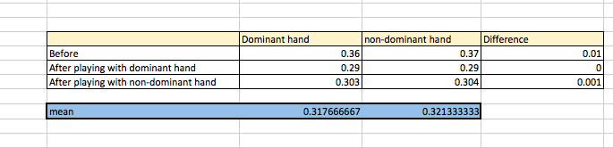
Figure 7 - Mean difference and average calculated to be able to do the paired t-test.
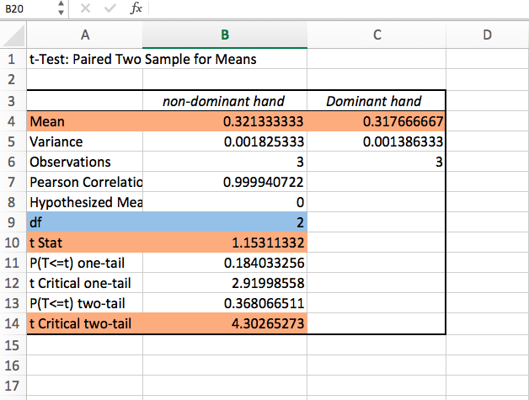
Figure 8 - Paired t-test done on Microsoft Excel.

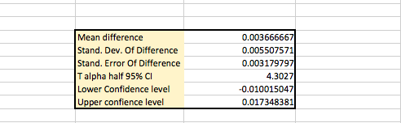
From the completed calculations, what we need the most is the mean, degrees of freedom, t stat, t critical value. All these calculations were then placed into a table to be able to calculate the standard deviation, standard error, lower confidence level and upper confidence level to come to a conclusion.

Figure 9 - Further calculations done for paired t-test on Microsoft Excel.
From we can tell that the results are likely to be a result of chance because p > 0.05 the p is 4.30427 therefore the difference is not significant, we used 0.05 because it shows reliability and accuracy. For example, in medical research you aim higher to p = 0,01 which is about 99% confidence in repeatability. This means my null hypothesis is correct, there is no relationship between reaction time using the dominant hand or the non-dominant hand.

Discussion

My experiment aimed to investigate the reaction time in students using the dominant versus the non-dominant hand after playing video games. After doing the t paired test, the results showed that there is no difference between the dominant and the non-dominant hand after playing video games because the t test was greater than the critical value. Therefore, the null hypothesis is correct.

However, after calculating the averages of dominant and non-dominant hand there is a clear yet a slight difference between dominant and non-dominant hand and it can be seen with my graph there is a slight difference of 0.01 (s). But to be fairly accurate it is not enough difference to show that there is a significant difference between the dominant and the non- dominant hand in a scientific matter.

Since my experiment was conducted on 100 participants which is good to get any kind of meaningful results, but a good maximum sample size is usually around 10% of the population (Robert, 2006). My results match the results of a previous study done by Nisiyama and Riberio that shows that reaction time of the right hand did not differ from reaction time of the left hand. It demonstrates that the left hemisphere dominance for motor control is not translated into a superior performance (a shorter latency for responding) of the right hand in reaction time tasks, independently of the complexity of the required response, the responding mode, and of the possibility or not of advanced preparation of the response. (Nisiyama and Riberio, 2014)

Evaluation and improvements

There were a few errors and other factors that could have affected my results, these variables are listed in the table below.
Affecting variables | Effect on data | Improvement
Some participants may have played video games outside of school. | This could have affected the reaction time when they were using their dominant and non-dominant hand, it might have shown no difference because they already use both hands while playing video games nearly every day. | Asking the participants who are gamers to not play video games for 12 hours previous to the experiment so it would not affect the reaction time during the experiment.
Participants may have inadvertently not switched hands during the experiment. | If some participants did not use dominant and non-dominant hand while doing the experiment this would lead to the data being inaccurate and the results being unreliable because it does not measure dominant vs non-dominant hand. | Be very clear while giving the participants instructions on when to use dominant and non-dominant hand and how important it is to not be dishonest.
Participants may have known the game or played the game before. | This would not give me accurate reaction time results since they are already used to this sort of stimuli therefore they are playing the game again for 2 times would have given me a different result perhaps higher than it would be if they did not know the game. | Choose a game that is not known to the participants so they would not perform better.

Conclusion

After my experiment was conducted and statistical analysis conducted, we can conclude that there is no significant difference between reaction time in dominant and non-dominant hands after playing video games. There was only a difference of 0.01 (s) after calculating the average of 100 students which is not enough to say that dominant hand is faster than non-dominant hand.

Although, many factors could have affected one’s reaction time such if they are already gamers, they use their dominant and their non-dominant hand equally, if they have consumed any sort of caffeine or alerting drinks that could have manipulated the reaction time in some way.

However, individual reaction times decrease as they become more familiar with the test (Amberly Diep, 2014) and since they have repeated the test 5 times for each hand this could have affected their reaction time therefore makes the results not reliable enough. We accept the null hypothesis, it was expected that using the dominant hand would increase reaction time because it is the one we use the most, it is stronger, we developed hand tendency from our ancestors but on the other hand, factors such as age, vision, hearing and cognitive process in one’s brain may have changed the results in some way.
The reason why there is no difference between right and left hand could be because the preferred hand is not always a good guide to the dominant hemisphere. Derakhshan (2006 & 2009) found that a minority of right handed people actually had a dominant right hemisphere, and that reaction time on the right side of the body was slower in these people because commands had to originate in the right hemisphere and then cross over to the left hemisphere, and then get to the right hand. In other words, the side of the body with the longer reaction time (not always the side with the non- preferred hand) is the side with the dominant hemisphere. (Derakhshan 2006 & 2009). This could be the reason why there was no difference between dominant and non-dominant hand and how that affected reaction time through video games.

The results of this experiment could be beneficial for me because now I can understand the effect of video games on high school students, I can have a clear understanding of how dominant and non-dominant hand work and the link between them and the hemisphere of the brain. I can now apply this knowledge and aid those who play video games or sports about hand dominancy and that both hands have approximately the same reaction response and therefore both hands should be used more frequently to achieve better results during competitions.

To expand this experiment and look for more scientific reasons behind reaction time in dominant and non-dominant hands, further experiments could be done on the hemisphere of the brain and its relation to hand dominancy.

Bibliography
Li et al (2014). Handedness- and Hemisphere-Related Differences in Small-World Brain Networks: A Diffusion Tensor Imaging Tractography Study. Retrieved from NCBI: https://www.ncbi.nlm.nih.gov/pmc/articles/PMC3961786/#B38

Anonymous. (2017). What is reaction time or response time? Retrieved from Cognifit: https://www.cognifit.com/science/cognitive-skills/response-time

Anonymous. (n.d.). Factors Affecting Reaction Time. Retrieved from California Training Institude : http://www.cti-home.com/wp-content/uploads/2014/01/Factors-Affecting-Reaction-Time1.pdf

Bartee, H. H. (1971). An investigation of simple reaction time and movement time of the dominant and non-dominant hand of elementary school children.Retrieved from https://digital.library.unt.edu/ark:/67531/metadc131393/m2/1/high_res_d/n_04296f.pdf

Blank-Rochester, A. (2010). Video games speed up reaction time. Retrieved from Futurity: http://www.futurity.org/video-games-speed-up-reaction-time/

Cenzon, M. (2016). 10 Positive Effects Of Video Games. Retrieved from Symptom Find: https://www.symptomfind.com/health/positive-effects-of-video-games/

Christopher, D. (2017). The Negative Effects of Video Game Addiction. Retrieved from live strong: https://www.livestrong.com/article/278074-negative-effects-of-video-game-addiction/

Cognitive Training. (n.d.). Retrieved from Brain Metrix: http://www.brainmetrix.com/cognitive-training/

Custers, E. (2017). Owlcation. Retrieved from Reflex Action and Reflex Arc: What Happens When You Accidentally Touch a Hot Pot: https://owlcation.com/stem/Here-is-what-happens-when-you-accidentally-touch-a-hot-pot

Daphen Baevlier: your brain on video games (2014). Retrieved from Ted Summaries: https://tedsummaries.com/2014/12/30/daphne-bavelier-your-brain-on-video-games/

Diep, A. (2014). Effect of Dominance & Non-Dominance on Reaction Time. Retrieved from Prezi : https://prezi.com/i3o7m8y197z-/effect-of-dominance-non-dominance-on-reaction-time/
Efron, P. N. (2010). Can looking at a computer screen affect your eyesight? Retrieved from ABC health & wellbeing: http://www.abc.net.au/health/talkinghealth/factbuster/stories/2010/09/30/3025732.htm

Experiment: How Fast Your Brain Reacts To Stimuli. (n.d.). Retrieved from Backyard Brains: https://backyardbrains.com/experiments/reactiontime
Geiling, N. (2013). Why Are Some People Left-Handed? Retrieved from Smithsonian: https://www.smithsonianmag.com/science-nature/why-are-some-people-left-handed-6556937/

Goldman, J. G. (2014). Evolution: Why are most of us right-handed? Retrieved from BBC FUTURE: http://www.bbc.com/future/story/20141215-why-are-most-of-us-right-handed

Grubb, J. (2014). Gaming advocacy group: The average gamer is 31, and most play on a console. Retrieved from Venture beat: https://venturebeat.com/2014/04/29/gaming-advocacy-group-the-average-gamer-is-31-and-most-play-on-a-console/

Hammond, R. E. (n.d.). Reactions and Reflexes. Retrieved from Carolina: https://www.carolina.com/teacher-resources/Interactive/reactions-and-reflexes%3F/tr23009.tr

Hille, R. (2012). Dominant vs. Non Dominant hand. Retrieved from abs.goc.au: http://www.abs.gov.au/websitedbs/CaSHome.nsf/home/downloadable+files.es/$FILE/Roisin+Hille_Reaction+Times.pdf

Kardaras, E. (2004). The Effect of Video Games on the Brain. Retrieved from Serendip Studio: http://serendip.brynmawr.edu/exchange/serendipupdate/effect-video-games-brain

Levin, M. (n.d.). Embroyic Left-Right Asymmetry. Retrieved from http://web.mit.edu/7.72/restricted/levin_lecture.pdf

Macarty, M. (2012). How to Run a Paired Samples t-test in Excel. Retrieved from Youtube: https://www.youtube.com/watch?v=wy8GVt7Ityk

Mackane, J. (2016). There are 1.8 billion gamers in the world, and PC gaming dominates the market. Retrieved from my gaming: https://mygaming.co.za/news/features/89913-there-are-1-8-billion-gamers-in-the-world-and-pc-gaming-dominates-the-market.html

Mackenzie. (1998). Reaction Time. Retrieved from Brainmac: https://www.brianmac.co.uk/reaction.htm

Niles, R. (2008). Statistics Every Writer Should Know. Retrieved from robertniles: http://www.robertniles.com/stats/
Nisiyama, M. &. (2014). Relative performance of the two hands in simple and choice reaction time tasks. Retrieved from NCBI: https://www.ncbi.nlm.nih.gov/pmc/articles/PMC3932976/#B29

Paired Sample T-Test. (n.d.). Retrieved from StatisticsSolutions: http://www.statisticssolutions.com/manova-analysis-paired-sample-t-test/
Playing action video games can boost learning. (2014). Retrieved from University of Rochester: http://www.rochester.edu/newscenter/playing-action-video-games-can-boost-learning-78452/

Red Light - Green light Reaction Time Test. (n.d.). Retrieved from Faculty Washington: https://faculty.washington.edu/chudler/java/redgreen.html

Reflex Arcs. (n.d.). Retrieved from IB Bioninja: http://ib.bioninja.com.au/options/option-a-neurobiology-and/a4-innate-and-learned-behav/reflex-arcs.html

Shier, R. (2004). Statistics: 1.1 paired t-tests. Retrieved from Statstutor: http://www.statstutor.ac.uk/resources/uploaded/paired-t-test.pdf

Significance testing (t-tests). (n.d.). Retrieved from Research Rundowns: https://researchrundowns.com/quantitative-methods/significance-testing/

Walpole, B. (2014). Biology for the IB Diploma. England : Cambridge (Cambridge university press) . Retrieved from http://www.radford.edu/jkell/Reaction%20Times.pdf

Wetsman, N. (2016). Do Other Animals Show Handedness? Retrieved from Science Friday: https://www.sciencefriday.com/articles/do-other-animals-show-handedness/

What causes some people to be left-handed, and why are fewer people left-handed than right-handed? (n.d.). Retrieved from Scientific American: https://www.scientificamerican.com/article/what-causes-some-people-t/

Why are most people right handed? The answer may be in the mouths of our ancestors. (2017, January 11). Retrieved from The Conversation: http://theconversation.com/why-are-most-people-right-handed-the-answer-may-be-in-the-mouths-of-our-ancestors-69712

Appendices

Appendix 1 - Raw data
Participant | Age | Gender | Before DH | BEFORE NDH | Average score DH AFTER PLAYING WITH DOMINANT HAND | NON-dominant hand after playing with dominant hand | Average score dominant hand AFTER PLAYING WITH NON-DOMINANT HAND | Non-dominant hand after playing with non-dominant hand
1 | 14 | Female | 0.3908 | 0.3582 | 0.3662 | 0.3929 | 0.3632 | 0.3639
2 | 14 | female | 0.3708 | 0.3250 | 0.3439 | 0.3531 | 0.3824 | 0.3959
3 | 14 | Female | 0.398 | 0.294- | 0.3161 | 0.3177 | 0.3064 | 0.3266
4 | 14 | male | 0.241 | 0.29 | 0.2136 | 0.2724 | 0.28 | 0.2844
5 | 14 | male | 0.2 | 0.266 | 0.307 | 0.2984 | 0.4729 | 0.698
6 | 14 | male | 0.325 | 0.271 | 0.2808 | 0.2634 | 0.2864 | 0.3084
7 | 14 | male | 0.2661 | 0.2987 | 0.3124 | 0.3215 | 0.3345 | 0.3783
8 | 14 | male | 0.32 | 0.209 | 0.2912 | 0.2472 | 0.2244 | 0.3418
9 | 14 | male | 0.377 | 0.376 | 0.316 | 0.2152 | 0.3002 | 0.2912
10 | 14 | male | 0.293 | 0.288 | 0.2515 | 0.3411 | 0.2901 | 0.2898
11 | 14 | male | 0.284 | 0.290 | 0.2832 | 0.264 | 0.2664 | 0.2682
12 | 18 | male | 0.26 | 0.266 | 0.2536 | 0.2554 | 0.2674 | 0.2611
13 | 17 | male | 0.315 | 0.326 | 0.319 | 0.306 | 0.312 | 0.343
14 | 17 | male | 0.342 | 0.351 | 0.3072 | 0.2932 | 0.2981 | 0.2771
15 | 17 | male | 0.527 | 0.3662 | 0.318 | 0.2704 | 0.3144 | 0.2934
16 | 15 | female | 0.356 | 0.3282 | 0.2792 | 0.3219 | 0.2910 | 0.3118
17 | 17 | male | 0.467 | 0.316 | 0.371 | 0.3706 | 0.2489 | 0.2561
18 | 18 | male | 0.278 | 0.298 | 0.3084 | 0.2642 | 0.2945 | 0.3150
19 | 17 | male | 0.353 | 0.313 | 0.3328 | 0.3186 | 0.3432 | 0.3577
20 | 17 | male | 0.577 | 0.666 | 0.2964 | 0.3074 | 0.2890 | 0.3155
21 | 15 | male | 0.704 | 0.890 | 0.3544 | 0.2938 | 0.3190 | 0.3201
22 | 17 | male | 0.372 | 0.422 | 0.2704 | 0.2622 | 0.2671 | 0.2311
23 | 16 | male | 0.409 | 0.567 | 0.3778 | 0.3302 | 0.3589 | 0.3282
24 | 14 | male | 0.259 | 0.338 | 0.279 | 0.2724 | 0.314 | 0.2181
25 | 14 | female | o.411 | 0.368 | 0.3134 | 0.3879 | 0.3281 | 0.3675
26 | 14 | female | 0.262 | 0.25 | 0.254 | 0.2608 | 0.2189 | 0.2345
27 | 14 | male | 0.403 | 0.26 | 0.344 | 0.3172 | 0.489 | 0.2781
28 | 15 | male | 0.3938 | 0.329 | 0.3142 | 0.3534 | 0.3290 | 0.3617
29 | 14 | male | 0.3158 | 0.3162 | 0.3144 | 0.319 | 0.3214 | 0.3298
30 | 14 | male | 0.3164 | 0.344 | 0.32 | 0.3772 | 0.475 | 0.3118
31 | 14 | male | 0.302 | 0.3114 | 0.3142 | 0.3258 | 0.3243 | 0.3321
32 | 15 | female | 0.37 | 0.294 | 0.2662 | 0.3102 | 0.2901 | 0.3124
33 | 14 | female | 0.333 | 0.375 | 0.2934 | 0.3100 | 0.3198 | 0.3356
34 | 14 | female | 0.381 | 0.364 | 0.3238 | 0.3098 | 0.3158 | 0.3267
35 | 14 | female | 0.433 | 0.539 | 0.3448 | 0.3627 | 0.3272 | 0.3233
36 | 15 | female | 0.322 | 0.3017 | 0.3039 | 0.2654 | 0.2981 | 0.3191
37 | 14 | female | 0.264 | 0.288 | 0.276 | 0.2854 | 0.2590 | 0.2986
38 | 15 | female | 0.331 | 0.356 | 0.3176 | 0.3142 | 0.3214 | 0.1922
39 | 14 | male | 0.33 | 0.31 | 0.2842 | 0.3502 | 0.3386 | 0.4450
40 | 14 | male | 0.393 | 0.389 | 0.293 | 0.2766 | 0.3346 | 0.4068
41 | 14 | male | 0.236 | 0.253 | 0.2718 | 0.3118 | 0.292 | 0.23
42 | 14 | female | 0.743 | 0.472 | 0.3210 | 0.2894 | 0.329 | 0.3494
43 | 14 | male | 0.225 | 0.241 | 0.2564 | 0.2774 | 0.2908 | 0.3096
44 | 14 | male | 0.262 | 0.320 | 0.3458 | 0.282 | 0.3068 | 0.2974
45 | 14 | male | 0.275 | 0.26 | 0.1796 | 0.262 | 0.2454 | 0.2806
46 | 15 | female | 0.373 | 0.35 | 0.258 | 0.2998 | 0.325 | 0.2782
47 | 16 | female | 0.372 | 0.228 | 0.3002 | 0.2686 | 0.846 | 0.284
48 | 14 | male | 0.105 | 0.25 | 0.3118 | 0.1682 | 0.1418 | 0.351
50 | 17 | male | 0.345 | 0.2899 | 0.2519 | 0.3828 | 0.2919 | 0.3372
51 | 17 | Male | 0.235 | 0.356 | 0.2718 | 0.2891 | 0.2289 | 0.2381
52 | 17 | Male | 0.298 | 0.467 | 0.2156 | 0.2371 | 0.2671 | 0.2516
53 | 17 | Female | 0.3478 | 0.3509 | 0.3182 | 0.3617 | 0.3561 | 0.3589
54 | 17 | Female | 0.467 | 0.2198 | 0.481 | 0.2224 | 0.2965 | 0.3165
55 | 17 | Male | 0.213 | 0.426 | 0.2246 | 0.2189 | 0.2476 | 0.2817
56 | 18 | female | 0.451 | 0.516 | 0.2718 | 0.2919 | 0.2617 | 0.2776
57 | 17 | female | 0.433 | 0.581 | 0.3781 | 0.3984 | 0.3461 | 0.3673
58 | 17 | Male | 0.234 | 0.346 | 0.2718 | 0.3256 | 0.2971 | 0.3192
59 | 16 | Male | 0.282 | 0.452 | 0.2171 | 0.2274 | 0.2675 | 0.2532
60 | 16 | Male | 0.338 | 0.443 | 0.2873 | 0.2964 | 0.2977 | 0.3199
61 | 17 | Male | 0.456 | 0.561 | 0.3718 | 0.3798 | 0.3819 | 0.3988
62 | 16 | Male | 0.277 | 0.312 | 0.2982 | 0.3182 | 0.2714 | 0.2865
63 | 18 | male | 0.561 | 0.435 | 0.2456 | 0.2677 | 0.3189 | 0.2945
64 | 17 | Female | 0.476 | 0.516 | 0.2464 | 0.2056 | 0.2371 | 0.2873
65 | 18 | Female | 0.566 | 0.452 | 0.3189 | 0.2918 | 0.3823 | 0.3617
66 | 17 | female | 0.361 | 0.276 | 0.2918 | 0.2764 | 0.2567 | 0.2467
67 | 18 | male | 0.221 | 0.287 | 0.2371 | 0.2114 | 0.2346 | 0.2127
68 | 15 | male | 0.45 | 0.283 | 0.2967 | 0.2998 | 0.3187 | 0.3195
69 | 15 | female | 0.572 | 0.2704 | 0.2872 | 0.2976 | 0.2764 | 0.2689
70 | 17 | female | 0.31 | 0.2813 | 0.3164 | 0.3273 | 0.2962 | 0.2845
71 | 17 | female | 0.442 | 0.2392 | 0.2197 | 0.2105 | 0.2470 | 0.2722
72 | 16 | Male | 0.481 | 0.3718 | 0.3891 | 0.2823 | 0.2817 | 0.3872
73 | 16 | Female | 0.378 | 0.441 | 0.3556 | 0.3784 | 0.2815 | 0.2764
74 | 17 | Female | 0.560 | 0.482 | 0.3278 | 0.3345 | 0.2819 | 0.3188
75 | 16 | Female | 0.472 | 0.593 | 0.2393 | 0.2546 | 0.3128 | 0.2981
76 | 17 | Male | 0.338 | 0.573 | 0.2140 | 0.2218 | 0.2389 | 0.2318
77 | 18 | Male | 0.211 | 0.298 | 0.2371 | 0.2483 | 0.2181 | 0.2112
78 | 17 | Female | 0.332 | 0.490 | 0.3084 | 0.2901 | 0.2864 | 0.3198
79 | 17 | Female | 0.281 | 0.311 | 0.2984 | 0.3134 | 0.2938 | 0.3289
80 | 16 | Female | 0.393 | 0.493 | 0.3183 | 0.2901 | 0.2478 | 0.2534
81 | 16 | Male | 0.29 | 0.287 | 0.2918 | 0.3281 | 0.2392 | 0.2217
82 | 18 | Male | 0.482 | 0.323 | 0.2873 | 0.2980 | 0.3293 | 0.2981
83 | 17 | Male | 0.182 | 0.328 | 0.2012 | 0.2337 | 0.3290 | 0.2890
84 | 17 | Male | 0.274 | 0.264 | 0.2781 | 0.2831 | 0.2594 | 0.2483
85 | 15 | Female | 0.401 | 0.563 | 0.3271 | 0.2913 | 0.3198 | 0.2780
86 | 16 | Female | 0.462 | 0.281 | 0.2481 | 0.2832 | 0.2563 | 0.2719
87 | 15 | Female | 0.385 | 0.442 | 0.3819 | 0.2981 | 0.2984 | 0.2913
88 | 17 | Male | 0.298 | 0.315 | 0.3781 | 0.3911 | 0.3372 | 0.3562
89 | 17 | Male | 0.394 | 0.403 | 0.2932 | 0.2832 | 0.3103 | 0.2812
90 | 16 | Female | 0.583 | 0.485 | 0.2193 | 0.2229 | 0.2561 | 0.3138
91 | 16 | Female | 0.227 | 0.317 | 0.3290 | 0.3374 | 0.3119 | 0.2831
92 | 16 | Male | 0.485 | 0.552 | 0.3192 | 0.3385 | 0.2983 | 0.2847
93 | 17 | Male | 0.28 | 0.216 | 0.2018 | 0.2194 | 0.2577 | 0.2673
94 | 17 | Female | 0.22 | 0.2937 | 0.3228 | 0.2743 | 0.2943 | 0.2873
95 | 18 | Female | 0.373 | 0.462 | 0.2674 | 0.2994 | 0.3198 | 0.3288
96 | 18 | Female | 0.381 | 0.490 | 0.3652 | 0.3726 | 0.2743 | 0.2955
97 | 17 | Male | 0.17 | 0.228 | 0.2163 | 0.2287 | 0.2471 | 0.2489
98 | 17 | Male | 0.411 | 0.246 | 0.2998 | 0.3178 | 0.2516 | 0.2677
99 | 17 | Male | 0.21 | 0.427 | 0.2273 | 0.2449 | 0.2183 | 0.2416
100 | 18 | Male | 0.235 | 0.416 | 0.2483 | 0.2590 | 0.2516 | 0.2771

Appendix 2 - Information sheet

Dear Student,
I am carrying out an IB Biology experiment in relation to my Extended Essay. The aim of this research experiment is to measure student reaction time using a simple reaction time test online after playing a video game for 5 minutes. This experiment will be done on the computer only during break and lunch time. The results of this experiment will remain confidential unless you wish otherwise, please be aware that you are free to withdraw from the experiment at any time.
Participating in this research experiment will help me drastically for my Extended Essay, it will be done in a very short time. If you wish to participate please fill out the form below and return it to me or your form teacher.

If you have any further questions, please do not hesitate to contact me.
Email: aliayehia98@hotmail.com

Thank you,
Alia Eissa 13A

Appendix 3 - Consent form

If you would like to take part in this research experiment, please read and agree to the terms stated below.

- I confirm that I have read and understood the information paper for the study, If I have any questions regards the experiment, I am able to ask Alia about it.

- I understand that my participation in this experiment is voluntary and that I am able to withdraw from it at any time.

- I agree to take part in this research experiment.

Name of the participant:

Date:

Signature:

Appendix 4 – t-test calculations

- D = Differences between two paired samples
- di = The ith observation in D
- n = The sample size
- d¯¯¯ = The sample mean of the differences
- σ^ = The sample standard deviation of the differences
- T =The critical value of a t-distribution with (n − 1) degrees of freedom
- t = The t-statistic (t-test statistic) for a paired sample t-test
- p = The p-value (probability value) for the t-statistic.
