Psychology HL INTERNAL ASSESSMENT

An experiment to investigate leading questions on memory distortion.

Word Count: 1997

Table of Contents
Abstract 3
Introduction 4
Method 5
Design 5
Participants 5
Materials 5
Procedure 5
Results 6
Descriptive 6
Inferential 7
Discussion 8
Bibliography 9
Appendices 10
Appendix 1 – Raw data 10
Appendix 2 – Questionnaire 12
Appendix 3 – Information sheet and consent form 13
Appendix 4 – Debriefing note 14
Appendix 5 – Briefing script 14
Appendix 6 – calculations 15
Appendix 7 – video 16

Abstract

The purpose of this experiment was to replicate Loftus and Palmer’s study to demonstrate that people’s memory can be manipulated by a previous information and wording of a question. Memory can be inaccurate. 20 international high school students participated in this study and were divided into 2 groups of 10. The first group were given a questionnaire that had a leading question and the verb used was ‘smashed’, while the other group had the verb ‘contacted’. The participants watched a 9 second video about a car crash and were asked a few questions about the speed of the car that was in the video. The experiment took less than 10 minutes, the participants were given a consent form, they were briefed and debrief and allowed to withdraw at any time. The results of this experiment showed that the leading verb ‘smashed’ and ‘contacted’ didn’t have an effect on the 16-yeard-old international high school students after they watched a short video about a car crash, therefore the null hypothesis is accepted. There is statistical significance between the leading verbs and the speed estimated and this can be due to the small sample size, having international students and the extraneous variables.

Word Count: 199

Introduction

Memory is the ability to remember previous experiences or recalling earlier learned facts and skills. Researchers have demonstrated that memory can be inaccurate due to it being influenced by other aspects than what was documented in the first place by our brain.

“A schema is a cognitive framework or concept that helps organize and interpret information. Schemas can be useful because they allow us to take shortcuts in interpreting the vast amount of information that is available in our environment” (Kendra Cherry, 2017) Bartlett (1932) described how schema influence memory in his research with ‘the war of ghosts’ story, he told British participants a legend about native Americans that was filled with anonymous names and concepts. He found that in the process of retelling the story, three developments occurred: levelling, sharpening, and assimilation which they made the story more familiar to them by changing it to fit with their cultural so it would be easy to remember. Finally, we know that prior schema may lead to memory distortions.

A study that supports Loftus & Palmer’s (1974) schema theory is Brewer and Treyens (1981) the study investigated whether a stereotypical schema of a regular office would affect memory recall of an office.
The participants were taken into a university student office for 35 seconds before going to another room, they were asked to write down as much as they could remember from the office. The participants remembered things they associate with a normal office according to their schema but they didn’t recall the wine and picnic basket because it wasn’t part of their regular office schema, this study supports how our schemas can affect cognitive processes in memory.

Loftus & Palmer (1974) did many experiments to demonstrate that people’s memory can be shaped by a post-event information and wording of a question. In this experiment, different groups of participants were asked the same questions but the critical words were changed. Nine participants were asked about the speed of the car when they hit each other but the critical word ‘hit’ was changed by ‘collided’, ‘bumped’ or ‘smashed’ or ‘contacted’ in the other conditions. The I.V was the different words used in the question and the D.V was the estimation of speed. The ‘smashed’ condition came through with mean of 40.8 (mph) and the mean of ‘contacted’ was 31.8 (mph) this indicates that the critical word in the question regularly affected the participant’s answer. When the words in the questions are changed it affects the participant’s representation of the car crash. ‘smashed’ triggers a cognitive schema of a severe accident that may change the participant’s memory of the speed of the car. This happens due to the expectation of cognitive schema we have of a sever accident, we usually forget the details of the car accident. It seems that participant’s memory of a car crash could be changed by using suggestive questions.

The aim of this experiment is to investigate the effect of using words such as ‘smashed’ and ‘contacted’ to describe a car accident on the memory recall of 16-year-old international high school students in the UAE This will be done on 20 participants and they will be divided into 2 groups of 10. The participants are of different ethnicities to avoid the experiment being ethnocentric.

Experimental hypothesis – The 16-year-old international high school students that get asked at which speed the cars were moving when the accident happens using the verb ‘smashed’ will estimate a much higher speed km/h than the participants who were asked about the accident using the word ‘contacted’.

Null hypothesis – The verb used such as ‘smashed’ or ‘contacted’ when asking the 16-year-old international high school students question about the accident will have no effect on the participant’s estimation on the speed.

Method

Design
We used an independent measure experimental design because it contains two different groups of participants each are in separate condition to avoid demand characteristics. This makes the experiment less time consuming and has no order effects. On the other hand, we cannot control the effects of participants such as different characteristics which may cause a confounding variable. (Lauren J Richards, 2016)

The independent variable was the verbs used to describe how fast the cars were going when they crashed, in the first condition the more intense verb was ‘smashed’ and in the second condition the less intense verb was ‘contacted’. The dependent variable was the speed estimation that the participants would write down. This would be measured using a questionnaire (See appendix 2). Moreover, both groups would be under the same conditions and the same video would be shown to all the participants to ensure accurate results. All participants were given a consent form to sign if they wanted to take part in the experiment. A briefing (See appendix 5) and debriefing (See appendix 4) was given to the participants explaining the aim, procedure and the results of the replicated experiment, participants were allowed to withdraw themselves or their results at any given time if they wished.

Participants
The target population is international students in the UAE born between 2000 and 1999. There were 20 participants taking part with an equal amount of gender in both groups, 5 females and 5 males in each group. An opportunity sampling was used to get participants to take part in the experiment, it is a quick way to obtain a sample because the group already exists however may not provide a representative sample and may be biased because they are a small group and all around 16-year-old. The participants were allocated to groups randomly through a random sampling generator online.

Materials

- A computer and a projector to show the videos to the participants.
- Questionnaires and pens given to the participants to write down their answers.
- An empty room for the experiment to take place so participants won’t get distracted.
- A consent forms.
- Briefing and debriefing script.
- A video.

Procedure

- The participants were randomly chosen to first group of the verb ‘smashed’ or second group of the verb ‘contacted’.
- Both groups were tested at the same time and same room but were told not speak or share answers with any other participant.
- An information sheet and consent form (See appendix 1) was given to both groups before starting the experiment.
- Questionnaires (See appendix 2) were given to the participants face down.
- Participants were briefed (See appendix 5) about the experiment and were given standardized instructions.
- A 9 seconds video (See appendix 7) was shown to the participants and then were asked to answer the questionnaires given to them quietly, group 1 had the verb ‘smashed’ and group 2 had the verb ‘contacted’.
- Questionnaires were collected from the participants and a debrief was given to them explaining the aim, procedure and it was made clear that they are allowed to withdraw their results any time.

Results

Descriptive

 | Mean | Standard Deviation
Group 1 (Smashed) | 66.5 | 33.34
Group 2 (Contacted) | 65 | 23.69

In the first group, the mean number of the verb ‘smashed’ was 66.5 and standard deviation was 33.34. In the second group, the mean number of the verb ‘contacted’ was 65 and standard deviation was 23.69. (Raw data see appendix 1)

Figure 1 - A bar graph showing the mean of group 1 'smashed' and group 2 'contacted'.

Figure 2 - A standard deviation graph showing the difference between group 1 and group 2.

Figure 1 shows that the mean numbers of word in ‘smashed’ is higher than the word ‘contacted’, smashed is (66.5) and contacted is (65) the mean here is used to measure of central tendency. Figure 2 shows the standard deviation which is a measure of the spread of scores within a data. The graph shows that group 1 ‘smashed’ has a high standard deviation of 33.34 which means that the numbers are more extended (less reliable), on the other hand group 2 ‘contacted’ has a low standard deviation of 23.69 which means that the numbers are very close to the average and it is more reliable.

Inferential
Ratio data was used to provide possibilities when it comes to statistical analysis (Market Research Guy, 2017) to test the significance of the results a Mann-Whitney test will be used (See appendix 6) because this experiment is an independent sample design and it is appropriate to use Mann-Whitney test as a statistical measure for this experiment.

The UA is 54 and its lower limit is 27 and upper limit is 73, UA 54 is larger than lower limit and smaller than upper limit. U has to be equal or less than the critical value. UA is more than the critical value at 0.05 which is 23 therefore we accept the null hypothesis. The verb used such as ‘smashed’ or ‘contacted’ when asking the 16-year-old international high school students question about the accident will have no significant effect on the participant’s estimation on the speed. In conclusion, the independent variable which was the verb used in the questionnaire did not cause the dependent variable which was the speed estimated of the car crash.

Discussion

The results of the experiment show that the leading verb ‘smashed’ and ‘contacted’ didn’t have a significant effect on the 16-year-old international students after they watched a short video about a car crash. This leads us to accept our null hypothesis which is the verb used such as ‘smashed’ or ‘contacted’ when asking the 16-year-old international high school students question about the accident will have no effect on the participant’s estimation on the speed. Our replication of the study by Loftus and Palmer does not match the results of their experiment which showed that the ‘smashed’ condition came through with the highest mean (40.8 mph) and the least was ‘contacted’ with mean speed estimate of 31.8 (mph) this indicate that the critical word in the question frequently affected the participant’s answer to the question. While our mean was 66.5 and 65 with a very small difference that doesn’t make it reliable enough. Our results are not as statistically significant as Loftus and Palmer’s. Similarly, Bartlett (1932) discovered the three processes of retelling a story which is levelling, sharpening and assimilation and the participants changed the story to fit it with their cultural and then would be easier to remember. Perhaps this is why the participants in this study choose different speed to fit in with what they have experienced before.

The strengths of using an independent measure design is that we reduce demand characteristics because different participants take part in the two groups so the participants can’t change their behaviour. Also, there is less chance of order effect because different participants took place and the experiment was fairly short and straight forward so the participants don’t feel bored or tired which can affect the results. However, we cannot control the confounding variables of each participants such as their characteristics and personality and these can always have an effect on our results.

There are several limitations, since it is an international school and we had participants from different ethnicities some of them were non- native English speakers so using the words such as ‘smashed’ and ‘contacted’ may not had a significant effect on their memory and schema because it is not a language they are familiar with. Our sample consisted of 16-year-old high school students therefore it is not representative to any group and makes it unreliable. Furthermore, participants may not be familiar with driving experience which then can affect the estimation they make.

To improve this study in the future, a larger sample of students could be chosen to have more accurate results, choose students who are have driving experiences so they would be able to make accurate estimation of the speed of the cars. In conclusion, our results were statistically insignificant and we accept our null hypothesis. The critical verb used does not have an effect on the speed estimated by the high school students.

Bibliography
Cherry, K. (2017). What Is a Schema in Psychology? Retrieved from Very Well Mind: https://www.verywellmind.com/what-is-a-schema-2795873
Guy, M. R. (2017). TYPES OF DATA & MEASUREMENT SCALES: NOMINAL, ORDINAL, INTERVAL AND RATIO. Retrieved from My Market Research Methods: http://www.mymarketresearchmethods.com/types-of-data-nominal-ordinal-interval-ratio/
Richards, L. J. (2016). Independent Measures Design. Retrieved from Getrivising: https://getrevising.co.uk/grids/independent-measures-design

Appendices

Appendix 1 – Raw data

For contacted

Male | Female
80 | 90
60 | 70
100 | 60
50 | 30
30 | 80

Average

Male | Female
64 | 66

For smashed

Male | Female
65 | 80
50 | 100
10 | 100
50 | 100
20 | 90

Average

Male | Female
39 | 94

Average for contacted and smashed

Contacted | Smashed
65 | 66.5

Standard deviation

Contacted

Male | Female
27.02 | 23.02

Smashed

Male | Female
23.02 | 8.94

Smashed | 33.34
Contacted | 23.69

Appendix 2 – Questionnaire

Questionnaire

Name
Gender
Age

- What was the color of the car that did not crash?

- How fast were the cars going when they smashed? (in km/h)

- Did you see a stop sign?

- Was there any broken glass?

- How many cars did you see?

Questionnaire

Name
Gender
Age

- What was the color of the car that did not crash ?

- How fast were the cars going when they contacted? (in km/h)

- Did you see a stop sign?

- Was there any broken glass?

- How many cars did you see?

Appendix 3 – Information sheet and consent form

Information sheet

Dear student,
We are carrying out an IB Psychology research experiment for our Internal Assessment which requires 20 students from year 11. This experiment will be done during form time on Sunday the 10th of December and will take no longer than 10 minutes, it will require you to watch a video about a car crash and then answering a few questions. If you agree to participate in this experiment you will be briefly introduced to the procedure at the very beginning. Your confidentiality will be maintained as your identity will be anonymous. Please be aware that you have the right to withdraw from the experiment at any time and to withdraw your results at the end of the experiment if you desire.

Taking part in this research experiment will help us immensely for our internal assessment, it will be done in a very short time. If you wish to participate please fill out the form below and return it to any of year 13 IB Psychology students or your form teacher.

Thank you,

Consent form

If you would like to take part in this research experiment, please read and agree to the terms stated below.

- I confirm that I have read and understood the information sheet for the research experiment, if I have any questions regarding the experiment, I am able to ask the IB psychology students about it.

- I understand that my participation in this experiment is voluntary and that I am able to withdraw from it any time.

- I agree to take part in this research experiment.

Name of the participant:
Date:

Signature:

Appendix 4 – Debriefing note

Debriefing Note:

Thank you for taking part in the experiment.

This experiment was carried out to replicate a study by Loftus and Palmer in which the aim was to investigate whether leading words, such as ‘smashed’ and ‘contacted’, in questions would affect the estimation of speed of both the cars in the crash.

By being a participant in our study, you have the right to withdraw your data anytime you want and you can learn about the conclusion of this experiment, after we analyse the results, by sending us an email. I would like to remind you that your confidentiality will be kept and the results will be anonymous.

Again, if you have any questions, don’t hesitate to send an email. Thank you again for taking part in the experiment.

Appendix 5 – Briefing script

Briefing script
Thank you for participating in our psychology experiment for our IB internal assessment.
First, we will give you an informed consent letter to sign, so when we tell you to, please take out a pen to sign. If you have any questions about the letter, don’t hesitate to ask.
We will show you a short video clip of a car accident, and would like you to answer the questions in the questionnaire provided.
The results will be used for our psychology internal assessment.
Your results are all confidential. You are allowed to withdraw your answers, and if you choose to do so, we will not include them in our results.
Please ask your questions now, and refrain from talking during the video and when writing down your answers.
Thank you!

Appendix 6 – calculations

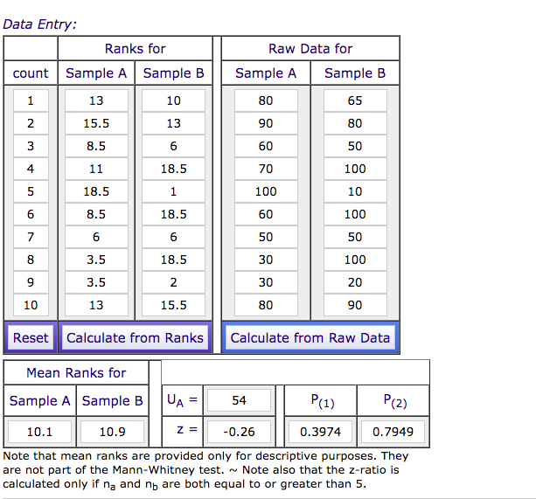
Raw data for Mann-Whitney Test

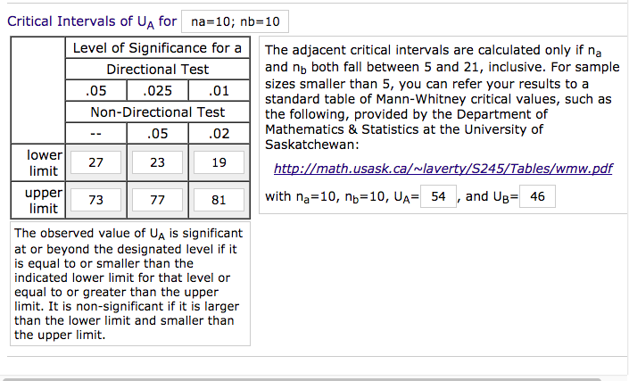

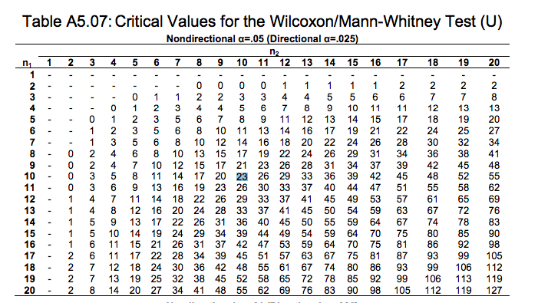

Appendix 7 – video

Video shown

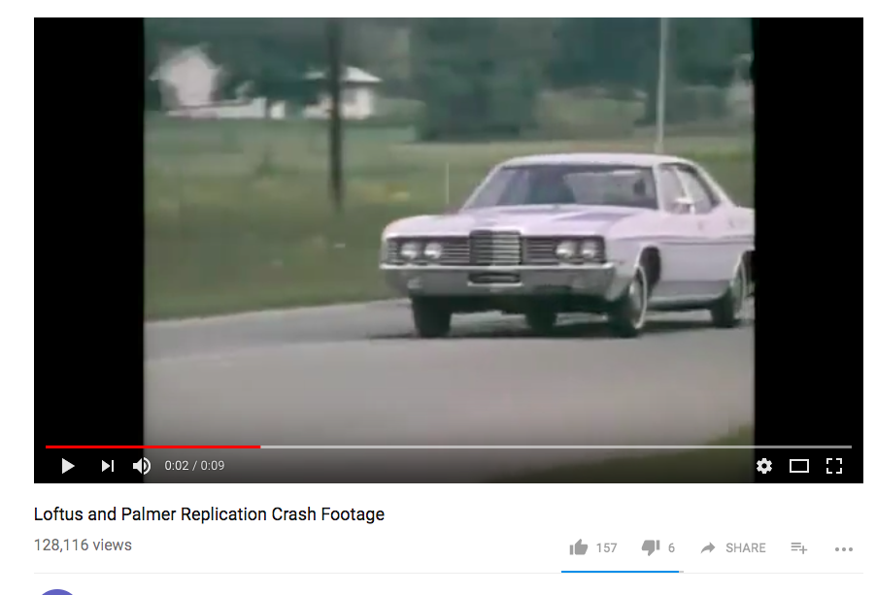

Retrieved from, https://www.youtube.com/watch?v=Rg5bBJQOL74&feature=youtu.be

